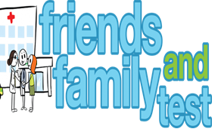
HAVE YOUR SAY TO IMPROVE YOUR CARE!
COMPLETE OUR SHORT QUESTIONNAIRE ON HOW LIKELY YOU ARE TO RECOMMEND OUR SURGERY TO FAMILY AND FRIENDS.
We have been collecting your replies and below are our results for
November 23
Very Good | Good | Neither Good/nor poor | Poor | Very Poor | Don’t Know
29 | 2 | 0 | 0 | 0 | 0

Recent comments:
- Excellent GP’S, polite reception staff and easy to book an appointment.

- Excellent surgery giving an old-fashioned service, and prompt appointments on offer. BRILLIANT!!
- Very friendly and professional staff, an excellent practice.
- We are so lucky to have such a great surgery, excellent doctors, and staff.

- The way this surgery operates is 2nd to none, amazing staff, Dr’s, and nurses. Personal service don’t ever change.

